

Foundations of Programming

Assignment No.: 18
PROBLEM STATEMENT: Write a C program that accepts a string from the user and performs the following string operations: i) Calculate length of string ii) String reversal iii) Equality check of two strings iv) Check palindrome v) Check substring.

OBJECTIVE:

- To understand basic string operations in C.
- To learn how to manipulate strings using loops and functions.
- To perform comparison, reversal, and substring checking.
- To check whether a string is a palindrome.

THEORY:
In C programming, a string is a sequence of characters terminated by a null character ('\0'). Strings are commonly stored in character arrays. Various operations can be performed on strings such as calculating their length, reversing the characters, comparing two strings, checking whether a string is a palindrome, and finding a substring within another string. These operations can be implemented using loops and conditional statements or by using standard library functions from the string.h header file.

ALGORITHM:
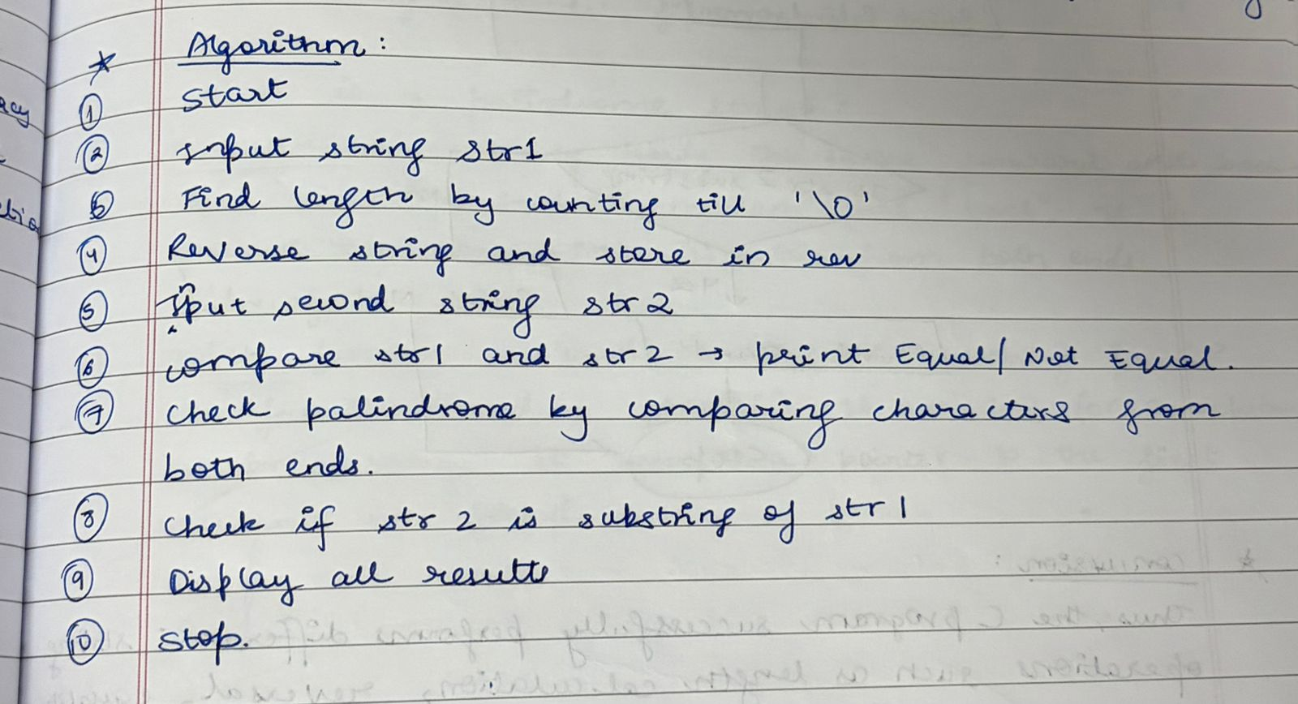
FLOWCHART:
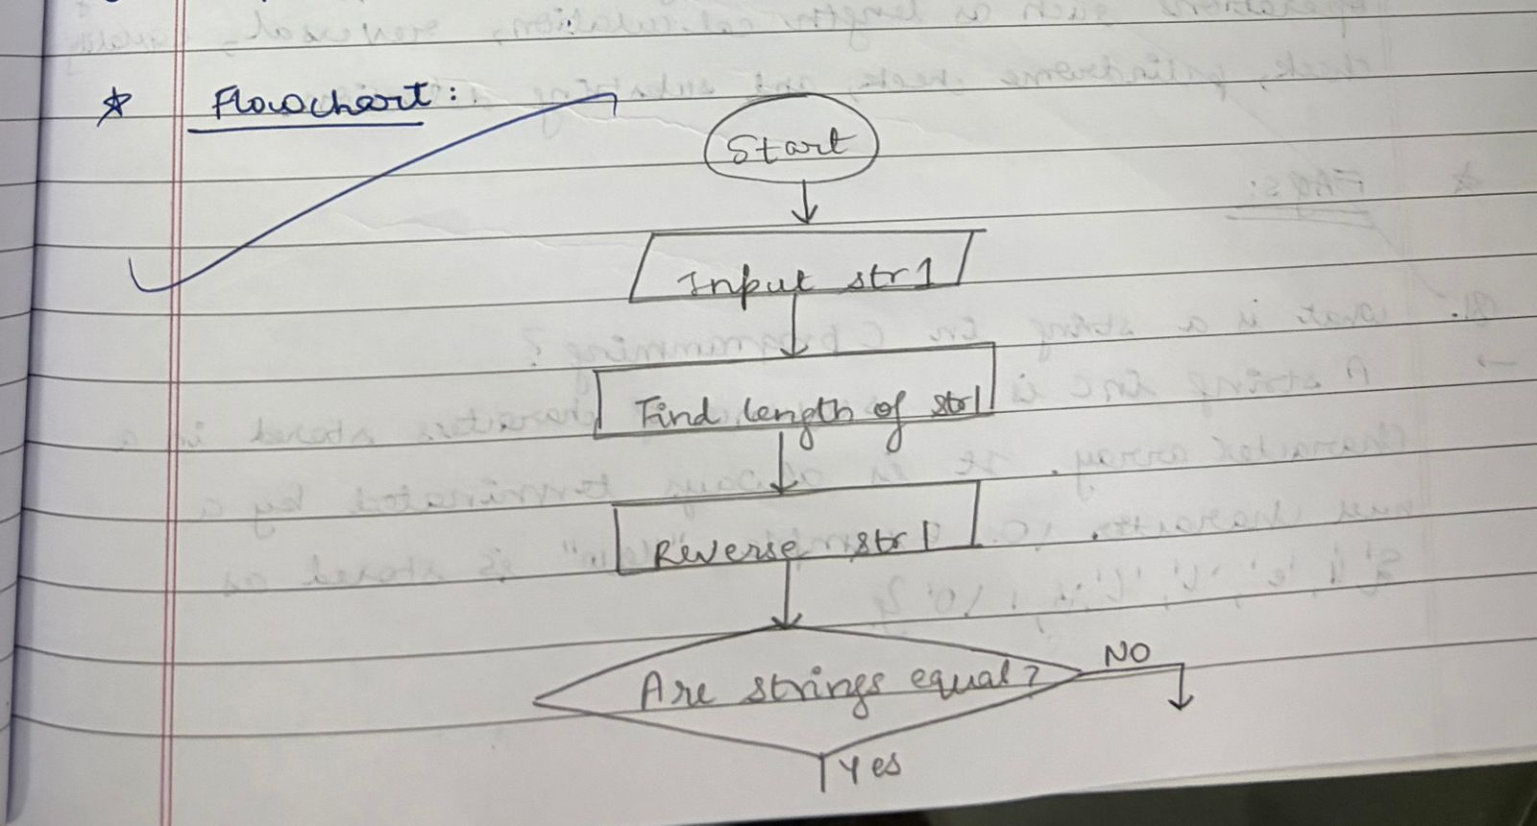
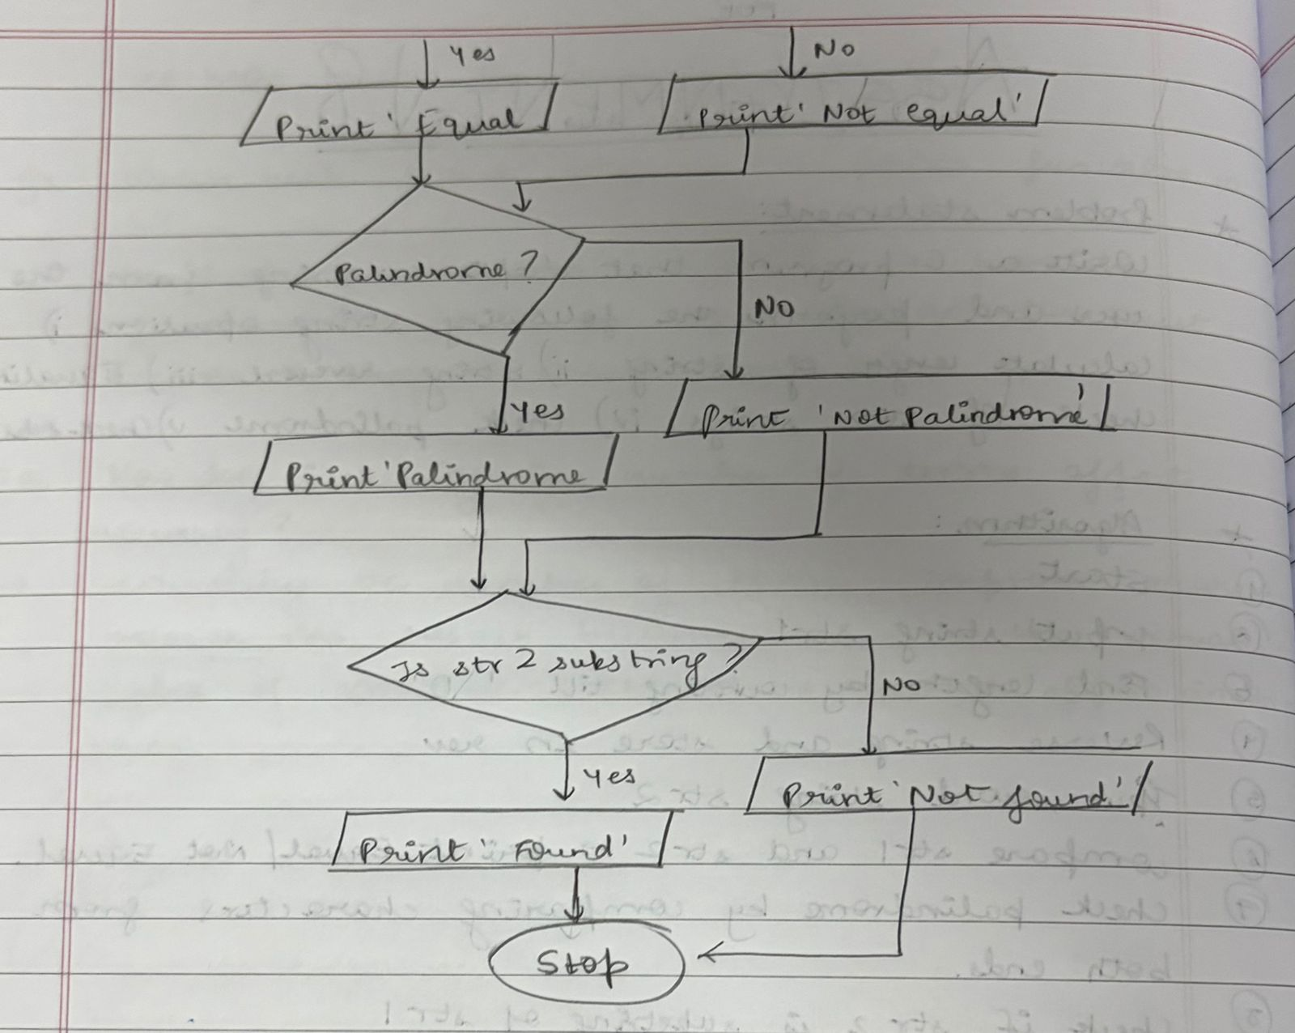
PLATFORM: Linux
CODE:
#include <stdio.h>
#include <string.h>

int main() {
char str[100], str2[100], rev[100];
int i, len, flag = 0;

// Input string
printf("Enter a string: ");
scanf("%s", str);

// i) Length
len = strlen(str);
printf("Length of string = %d\n", len);

// ii) Reverse string
for(i = 0; i < len; i++) {
rev[i] = str[len - i - 1];
}
rev[len] = '\0';
printf("Reversed string = %s\n", rev);

// iii) Equality check
printf("Enter another string for comparison: ");
scanf("%s", str2);

if(strcmp(str, str2) == 0)
printf("Strings are equal\n");
else
printf("Strings are not equal\n");

// iv) Palindrome check
if(strcmp(str, rev) == 0)
printf("String is a Palindrome\n");
else
printf("String is not a Palindrome\n");

// v) Substring check
if(strstr(str, str2) != NULL)
printf("Substring found\n");
else
printf("Substring not found\n");

return 0;
}

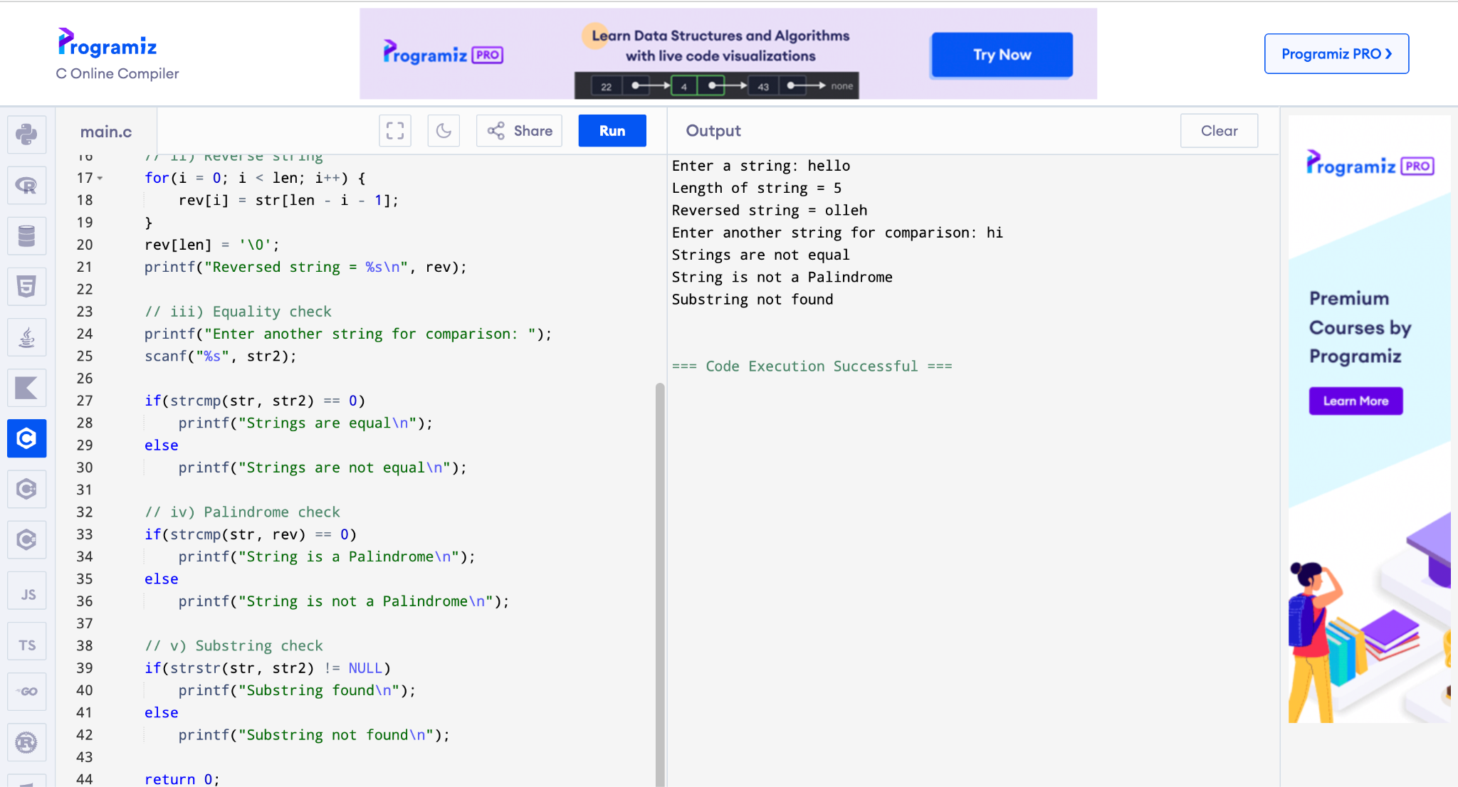

CONCLUSION: Thus, the C program successfully performs different string operations such as length calculation, reversal, equality check, palindrome check, and substring detection.

FAQs:
- What is a string in C programming?
- Which header file is required for string functions?
- What function is used to find the length of a string?
- What is a palindrome string?
- Which function is used to check a substring in C?

